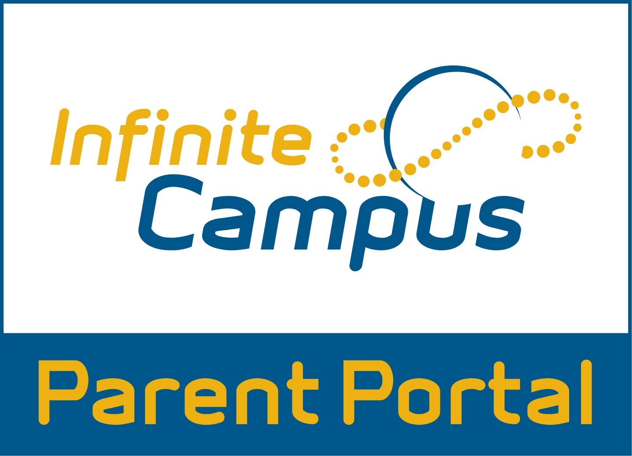
Grades
Westlake uses Infinite Campus (IC) for grades. IC is a fantastic tool because it is a live system. As soon as a grade is entered, parents and students can see it.

I recommend downloading the IC app on your smartphone. It will send you real time notifications of grades and attendance.

Students will earn one grade for Language Arts. The cumulative grade is based off of the Common Core Standards and is composed of scores for:
- Reading
- Writing
- Language
- Speaking & Listening

Students that earn a D or F should re-do the work and seek additional help.

Assessment grades greatly affect the final grade as it is worth 80%. Practice work is meant to practice and prepare for the assessments and will count for 20% of the overall grade in Language Arts.

Additional Help
I am available for additional help at students’ request. I expect students to take responsibility for their learning, so they should make an appointment with me by email for what day/time and I will be there.

I am usually available before school from 8:00am - 8:45am. Please verify with me about availability.
After school is not an option for additional help.

Contact Information
The most efficient method to contact me is through email. I also encourage students to contact me with questions or to make appointments via email.
- My email is Caitlyn.Mogensen@adams12.org
- My class website will have curriculum information, due dates, upcoming assessments and other valuable information. Please visit it!

My website is:
Mrs. Mogensen's 6th grade Language Arts Homework Page

I look forward to a fun, educational, and productive year! I thoroughly enjoy teaching Language Arts and I hope your child enjoys this class. I thank you for your support throughout this year.
Thank you!
Caitlyn Mogensen
6th Grade Language Arts
Westlake Middle School
Caitlyn.Mogensen@adams12.org

6th Grade
Language Arts
Wolf Pack Core

Ms. Mogensen

Schoology
Students will be keeping an interactive notebook this year in the classroom. We will also complete many of our activities and assignments on chromebooks. You can access students’ Schoology accounts with their Adams12 login.

Course Information
Students will engage in six units of study throughout the course of the school year. All skills learned in the first semester are spiraled in the second semester.
- Unit 1: Narrative
- Unit 2: Informational
- Unit 3: Argument
- Unit 4: Narrative
- Unit 5: Informational
- Unit 6: Argument

read.activelylearn.com
Flocabulary.com
Noredink.com
We will use these websites frequently throughout the year. It will be associated with your child’s Adams12 username and you can access it at home. These are awesome resources because they provide students with the opportunity to practice their reading, writing, and vocabulary skills.

Homework
Students should be reading 20-30 minutes a night at home. We will visit the library every two weeks to ensure that students have a choice book for this reading time. Students need to bring this choice book with them to class every day as well.

While I try to give enough time in class to finish assignments, it is the student’s responsibility to complete any unfinished or incomplete work and turn it in the next day.

Flashback Fridays
On Fridays, students will be given an opportunity to reflect on their learning and growth that week. As we embrace the idea of having a growth mindset as a 6th grade student, please ask your child about their growth at home. This is a great way to stay connected with how your child is feeling about class throughout the school year!

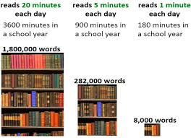

Late Work and Retakes
I will accept all work until the current quarter has ended. This policy applies whether the assignment was assigned at the beginning or end of the quarter. The only exception to this rule is when the excused absence policy applies.

Students may retake assessments until the end of the quarter. I will have designated retake days, but if those days do not work, the student is expected to set up a different time with me.

I will send periodic emails home about missing work. Please use IC to stay most informed about missing or incomplete work.

Behavior Expectations
Our class uses a system called Behavior Checks so students can self-monitor their behavior. When a student is engaging in a behavior that has negative academic, social, or behavioral consequences, students will receive a Behavior Check from me.

This is a personalized, private method created to prevent negative behaviors and to help resolve conflict.

Consequences for repeated Behavior Checks will be as follows:
- First Behavior Check in a month - Warning/no consequence
- Second Behavior Check - Parent Contact
- Third Behavior Check - Detention and or Reflective Conversation
- Fourth Behavior Check - Office Referral

The teacher reserves the right to skip some of these Behavior Check consequences if the situation is warranted. Additional consequences may also be given. Students’ behavior affects their eligibility to participate in the 6th grade end of year activities.

